**Dataset explanation:**

IMDB is one of the most sought-after rating platforms for movies. The data also contains the movie titles, rating, revenue, year of the content, etc. The data is very helpful in studying the impact of rating on the revenue of the movie. The data is also very helpful in finding correlations between genres, rating, and revenue.

### Assignment 1

1/1 point (graded)

Create a report where all the movies are ranked based on revenue in their respective genre. What is the rank of ‘Inception’ movie in it’s genre?

SELECT *

FROM (SELECT title,

genre,

revenue_millions,

Rank()

OVER (

partition BY genre

ORDER BY revenue_millions DESC) AS rank1

FROM imdb_movies) A

WHERE title = 'Inception'

### Assignment 2

1/1 point (graded)

Create a report where all the movies are ranked based on rating in their respective genre. What is the rank of ‘Star Trek’ movies in it’s genre?

Note: In case of the same rating, movies with higher number of votes should be ranked higher.

SELECT *

FROM (SELECT title,

genre,

rating,

votes,

Rank()

OVER (

partition BY genre

ORDER BY rating DESC, votes DESC) AS rank1

FROM imdb_movies) A

WHERE title = 'Star Trek'

### Assignment 3

1/1 point (graded)

Compute the revenue contribution of movies towards the total revenue of respective genres. What is the revenue contribution of the ‘Gone Girl’ towards its genre?

SELECT A.*,

( revenue_millions * 100 / total_genre_revenue ) AS percentage

FROM (SELECT title,

genre,

revenue_millions,

Sum(revenue_millions)

OVER (

partition BY genre ) AS Total_genre_revenue

FROM imdb_movies) A

WHERE title = 'Gone Girl'

### Assignment 4

1/1 point (graded)

Compute the percentage rating in terms of top rated movies in their respective genre. For example, a movie in ‘Action’ genre has maximum rating of 9, then percentage rating for all the movies in ‘Action’ genre would be (rating*100/9). What is the percentage rating of the movie ‘Blood Diamond’?

SELECT A.*,

( rating * 100 / max_genre_rating ) AS percentage_rating

FROM (SELECT title,

genre,

rating,

Max(rating)

OVER (

partition BY genre ) AS Max_genre_rating

FROM imdb_movies) A

WHERE title = 'Blood Diamond'

### Assignment 5

1/1 point (graded)

Segment the movies based on the below criteria using CASE WHEN

Revenue greater than or equal to 300 million : Blockbuster

Revenue between 200 and 299.99 million : Super hit

Revenue between 100 and 199.99 million: Hit

Else: Normal

How many movies are ‘Super hit’ in the year 2014?

SELECT result,

Count(title) AS number_of_movies

FROM (SELECT title,

genre,

revenue_millions,

year,

CASE

WHEN revenue_millions >= 300 THEN 'Blockbuster'

WHEN revenue_millions BETWEEN 200 AND 299.99 THEN 'Super Hit'

WHEN revenue_millions BETWEEN 100 AND 199.99 THEN 'Hit'

ELSE 'Normal'

END AS result

FROM imdb_movies) A

WHERE year = 2014

GROUP BY result

### Assignment 6

1/1 point (graded)

Segment the movies based on the below criteria using CASE WHEN

Revenue greater than or equal to 300 million : Blockbuster

Revenue between 200 and 299.99 million : Super hit

Revenue between 100 and 199.99 million: Hit

Else: Normal

What is the total revenue of the Blockbuster movies in the year 2015?

SELECT result,

Sum(revenue_millions) AS tot_revenue

FROM (SELECT title,

genre,

revenue_millions,

year,

CASE

WHEN revenue_millions >= 300 THEN 'Blockbuster'

WHEN revenue_millions BETWEEN 200 AND 299.99 THEN 'Super Hit'

WHEN revenue_millions BETWEEN 100 AND 199.99 THEN 'Hit'

ELSE 'Normal'

END AS result

FROM imdb_movies) A

WHERE year = 2015

GROUP BY result

### Assignment 7

1/1 point (graded)

Segment the movies based on ratings using IF statement as below:

Rating greater than or equal to 8: ‘Must Watch’

Rating between 6 and 7.9: ‘Can Watch’

Rating below 6: ‘Avoid’

How many movies are a ‘Must Watch’ in the entire dataset?

SELECT result,

Count(title) AS number_of_movies

FROM (SELECT title,

genre,

rating,

year,

IF(rating >= 8, 'Must Watch',

IF(rating BETWEEN 6 AND 7.9, 'Can Watch',

'Avoid')

) AS result

FROM imdb_movies) A

GROUP BY result

### Assignment 8

1/1 point (graded)

Compute total revenue by year and genre for all the movies with ratings less than 7. What is the total revenue of movies with ratings less than 7 in the year 2016 for ‘Drama’? Use IF statement.

SELECT year,

genre,

SUM(IF(rating **< 7**, revenue_millions, 0))

FROM imdb_movies

WHERE year = 2016

AND genre = 'Drama'

GROUP BY year,

genre

### Assignment 9

1/1 point (graded)

How many movies have NULL values in the field revenue?

SELECTCount(title)

FROM imdb_movies

WHERE revenue_millions IS NULL

### Assignment 10

1/1 point (graded)

What is the average rating of the movies which has revenue as NULL?

SELECT Avg(rating) AS avg_rating

FROM imdb_movies

WHERE revenue_millions IS NULL

### Assignment 11

1/1 point (graded)

If the revenue field for a movie is NULL, then assign the revenue as rating*revenue factor. Revenue factor = total revenue/ total rating (where revenue is not NULL)

What is the average revenue of all the movies for the year 2016 considering imputed values?

SELECT Avg(adj_revenue)

FROM (SELECT a.*,

Ifnull(revenue_millions, rating * (SELECT Sum(revenue_millions) /

Sum(

rating)

FROM imdb_movies

WHERE revenue_millions IS NOT

NULL))

AS

adj_revenue

FROM imdb_movies a) b

WHERE year = 2016

### Assignment 12

1/1 point (graded)

If the revenue field is NULL, consider it 0 using coalesce function.

What is the average revenue of all the movies for the year 2016 considering imputed values?

SELECT Avg(adj_revenue)

FROM (SELECT a.*,

COALESCE(revenue_millions, 0) AS adj_revenue

FROM imdb_movies a) b

WHERE year = 2016

### Assignment 13

1/1 point (graded)

A function that has no partial functional dependencies is in ______ form

2NF

### Assignment 14

1/1 point (graded)

Below table can be categorized in which normal form?

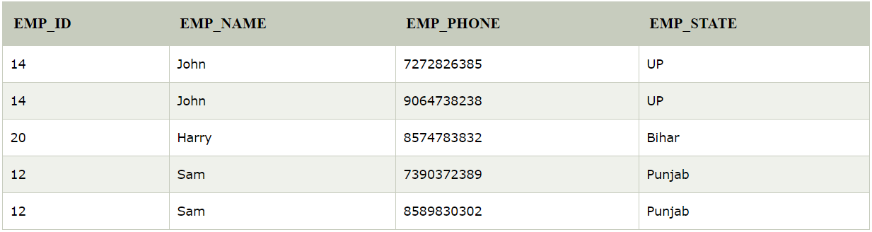

1 NF

2 NF***

3 NF

4 NF

### Assignment 15

1/1 point (graded)

The third normal form is based on the concept of _____

Closure dependency

Transitive Dependency ***

Normal Dependency

Functional Dependency

### Assignment 16

1/1 point (graded)

Denormalization is useful in less execution time for

Root cause analysis

Dashboards

Daily and weekly reports

Both B and C ***

### Assignment 17

1/1 point (graded)

A table is no longer required. But we want to retain the table schema, so that we can use it to create similar tables again. Which of the following statements should be used?

DROP

DELETE

### Assignment 18

1/1 point (graded)

Below are the two representative queries on table1 (80 rows) and table2 (40 rows).

All the 40 rows in table 2 matches with table1.

Query 1:

SELECT *

FROM table1 a

LEFT JOIN table2 b

ON a.column1 = b.column

Query 2:

SELECT *

FROM table1 a

LEFT JOIN table2 b

where a.column1=b.column1

Both the queries will have same output (80 rows)

Both the queries will have same output (40 rows)

Query 1 will give 80 rows while Query 2 will give 40 rows ***

Query 1 will give 40 rows while Query 2 will give 80 rows